Appendix 11 for Downton Neighbourhood Plan
Drainage, Sewerage System, Groundwater and Surface Water drainage

Summary
There are significant impacts to the community from high levels of groundwater on a regular basis. In extreme cases, these can lead to property flooding but on a regular basis during a wet winter (3 significantly raised groundwater levels in the last 10 years (winter 07, 13 and 14) – see graphs below from Environment Agency groundwater borehole records) there are regular overflows from the sewers and surface water drainage system in many locations onto roads and pavements as a result of groundwater infiltration. This can also lead to large numbers of properties, including the Trafalgar School, being unable to use toilets, washing machines, baths etc with temporary toilets being erected outside resulting in public health and stress related issues. To alleviate some of the problems, Wessex Water have installed temporary pumps during periods of high groundwater to pump directly from the sewers to the River Avon as an emergency measure. The River Avon is a SSSI and SAC with strict controls on unregulated discharges. The frequency of use of temporary pumps is not considered to be justified as an “emergency measure” long term and other solutions have to be pursued while minimising further contributions to the problem through development.

In terms of development in the village, this requires the following policies and actions:
- All drainage systems need to be sealed to prevent groundwater ingress, particularly at connections from premises to sewer systems and need to be tested and certified to ensure efficacy when connected;
- All surface water drainage needs to consider high groundwater levels in terms of ability of any sustainable drainage systems to function and overland flows entering drainage systems and sewers through manholes;
- Wessex Water to complete and implement an Infiltration Reduction Plan.

Evidence

Sewer Flooding
One of the most frequent issues raised by residents in Downton is sewer flooding. Recent consultations on the neighbourhood plan and responses to the Charles Church development of 99 properties in Downton, revealed both the frequency and impact. At the consultation on the Charles Church Development and extension of the village school into the Memorial Grounds, around 10% of responses raised the issue of sewer flooding – this is a high unsolicited response rate. The impact was evident in 2013/14 where such problems were particularly acute at:
- The Trafalgar School: From mid-December through to mid-March, up to four tankers per day, seven days per week, had to come onto the school site in order to prevent sewage flooding that would otherwise have forced the school to close. The school also had to deploy temporary toilets for two weeks to avoid flooding of sewage within the school buildings.
- Wick Lane: For four months untreated sewage, along with toilet paper etc., fountained continuously out of manholes and ran across the road in Wick Lane. When vehicles drove through it, any pedestrians walking by at the time were sprayed with contaminated water.
- Long Close: Over the same four months, untreated sewage, along with toilet paper etc., gushed continuously out of a manhole and ran across the footpath which connects Long Close West and Long Close East. This footpath is the principal route used by the many parents who live to the west of the A338 in Downton (Greenacres, Wick Lane, West Wick, Clearbury View, Mesh Pond and, if planning permission is granted, the Charles Church development) when taking their young children to and from Downton Primary School or Downton Community Pre-School in Gravel Close. As the manhole is on the edge of the footpath, and the ground slopes downwards from the manhole to the other side of the footpath, anyone walking along Long Close could not avoid walking through this contamination and bringing it with them on their shoes into the pre-school and primary school.

The sewer flooding is caused by high levels of groundwater following periods of high rainfall. The groundwater infiltrates the sewer system, generally through joints and connections between pipes and manholes but also through cracks and seepage as a result of groundwater pressure. The high groundwater levels are evident throughout the Avon Valley with the Environment Agency starting to issue flood warnings based on improved monitoring information and flood risk data. There are several locations throughout the village where high groundwater levels are evident, in low spots in Gravel Close for instance and also groundwater emerging from the ground in several places on the east side of Downton where groundwater levels were also high with water running across pavements on the High Street opposite the Chemists for example. The following charts, from Environment Agency borehole data, show the groundwater levels in recent years. The peaks in 2007, 2013 and 2014 are when the impacts were particularly severe, although groundwater ingress occurs into the sewer systems on all but dry years.

It is interesting to note that the level of the groundwater table is less than 1.0m in the majority of winters; Environment Agency advice to Wiltshire Council as planning authority re the Charles Church development is for a requirement for a 1m zone of separation between the proposed drainage infrastructure that will serve the proposed development and the water table itself. This means that drainage systems reliant on soakaways in most parts of the village will not work for long periods of time as well as the groundwater levels exerting significant pressure on the sewer systems which will be below the groundwater table for lengthy periods of time in many locations.

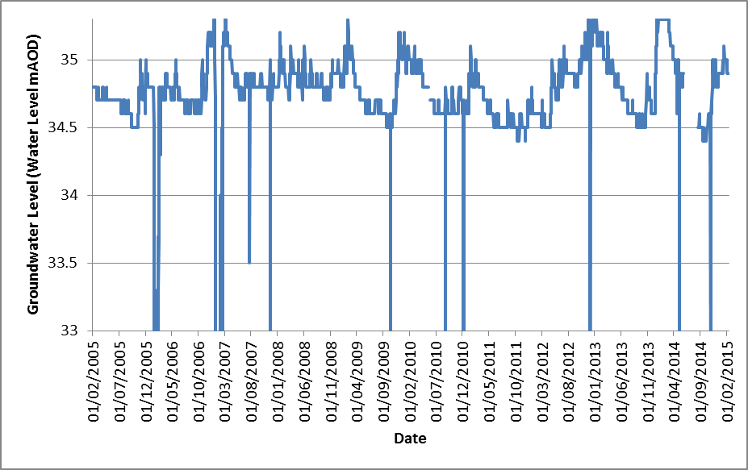
Table x.x Groundwater level at Memorial Gardens Borehole. Most of the Memorial Gardens height is 36.0m AoD

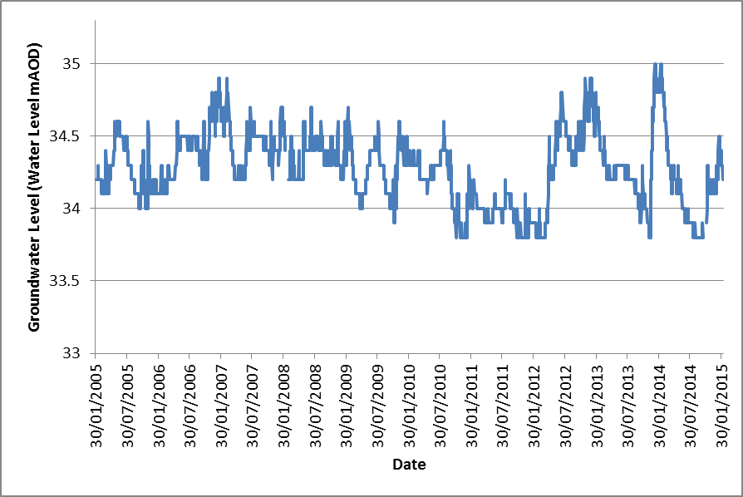
Table x.x Groundwater level at Fishermans Stile (Easting 417732, Northing 121506)

Wessex Water has recognised the problem of groundwater inundation of the sewer system in Downton for several years. Wessex Water has undertaken CCTV surveys of the sewer system to locate hot spots and then instituted programmes to seal the sewers. To date, the sealing of sewers has had little effect because of ingress of groundwater through the many connections into the main sewer system. The action by Wessex Water to mitigate the sewer flooding in 2013/14 was a mixture of pumping and tankering from specific locations to the Downton Sewage Treatment Works and over-pumping from the sewer system next to their pumping station at South Lane into the River Avon in order to reduce levels in the sewer system. The over-pumping to the River Avon would normally require a discharge consent. The Environment Agency, who regulate discharge consents under the Water Resources Act, has a Regulatory Position (Source Environment Agency Regulatory Position Statement on Discharges made from Groundwater Surcharged Sewers May 2014) that accepts emergency discharges from Water and Sewerage companies in these situations providing that they are notified, the need is justified and there are other mitigation measures such as screening of effluent. The Environment Agency has recognised the increase in groundwater flooding and the impacts caused by inundation of sewers and consequent sewer flooding in recent years by requiring an Infiltration Reduction Plan (IRP) to be put into place for communities impacted. Wessex Water has the responsibility to put these in place in consultation with the Environment Agency and Wiltshire Council as Lead Local Flood Authority. They are prioritising their production of IRPs and have identified the need to produce an IRP for Downton.

Wessex Water have discussed the likely IRP outcomes with Parish Councillors and consider that the IRP will require further investigations and sewer sealing programmes but that the extent of locations where groundwater infiltration is occurring into their sewer system is so extensive as to make a full sewer sealing system prohibitively expensive and not cost effective. Wessex Water therefore believe that a permanent emergency discharge is required, probably close to their South Lane pumping station in Downton, to pump, with screening and environmental protection measures, from the sewer system to the River Avon when groundwater levels are inundating the system and causing sewer flooding problems. The River Avon is a SSSI and SAC and discharge consents would normally not be allowed without treatment despite the discharges being predominantly “clean” groundwater with very low environmental impacts. This permanent solution would only be allowed with a well justified case following the implementation of the IRP and should require actions to mitigate the use of the emergency discharge such as periodic CCTVs and sealing of sewers and a policy requiring future connections to the system to be fully sealed and tested and minimising ingress of surface water and groundwater to the sewer system through manholes.

The latter is a requirement of Wessex Water to the development by Charles Church. This is the justification for including a policy within the Neighbourhood Plan requiring connections to the sewer system to be sealed and tested to the specifications and satisfaction of the Water and Sewerage Company (Wessex Water). This would apply to all development applications, including extensions and renovations as well as new planning applications.

Surface Water Drainage
Surface water flood risk is a recognised problem and generally covered by Flood Risk Assessments in the planning system. Surface water flood risk has been mapped by the Environment Agency and the map for Downton is included below.

Map (needs better link) 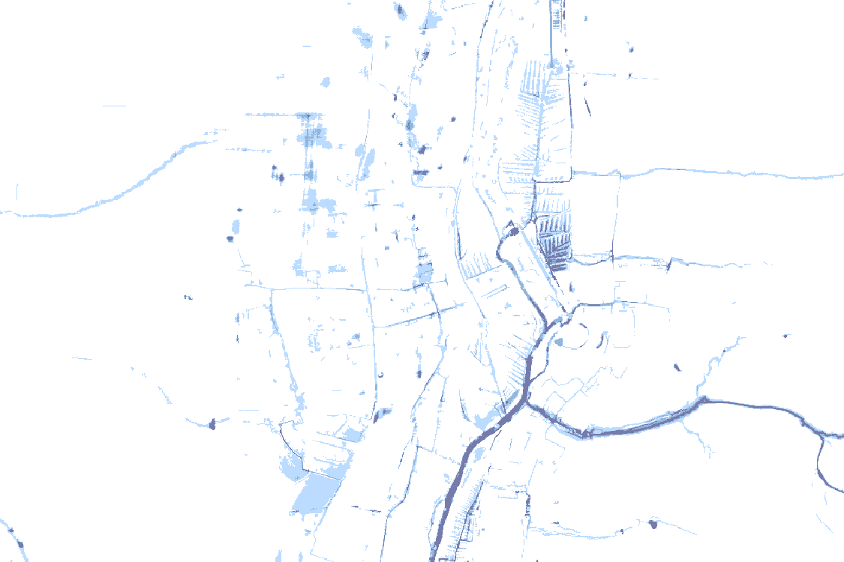

The surface water map does not consider the interaction of high groundwater levels on the drainage system. In particular, the use of Sustainable Drainage System (SuDS) techniques to manage surface water flooding may not work during periods of high groundwater. The infiltration into the water table of (SuDS) relies on having an unsaturated and highly permeable layer beneath the SuDS system. The geology of the Avon Valley is very permeable and such systems would be appropriate provided that there is sufficient depth between the water table and the system. In many parts of Downton, the depth of the water table is under 0.5m under high groundwater conditions and therefore makes SuDS inappropriate for use. This is because instead of infiltrating into the water table rainwater and surface water will pool and cause overland flow during high rainfall events. This can cause flood risk as well as inundation of other drainage systems (sewers and surface water) as a result.

The Neighbourhood Plan therefore needs to include a requirement for all development applications to undertake a Flood Risk Assessment and develop drainage plans that take into account high levels of groundwater.

